DriveTime API

A Database for Professional Car Dealerships



Aniese Tates

**COSC 457 Database Management Systems**

**Towson University**

**Fall 2019**

David Nsoesie

Amanuel Challa

Mike Achianga

**Introduction**

The drive time car dealership was is a car dealership where customers can come in buy a car or run, safe customer information, run car maintenance on purchased cars for customers.

The administrative sector keeps or store inventory systems of customers purchases, and customer’s information.

**Who should access and use this site**

This site is intended for Customers around the country:

* Administrators: Administrative users log in to their accounts and manage employee timecards and expenses. They additionally view and modify information about employees and sales made.

For more information customers should contact customer service of the dealership company.

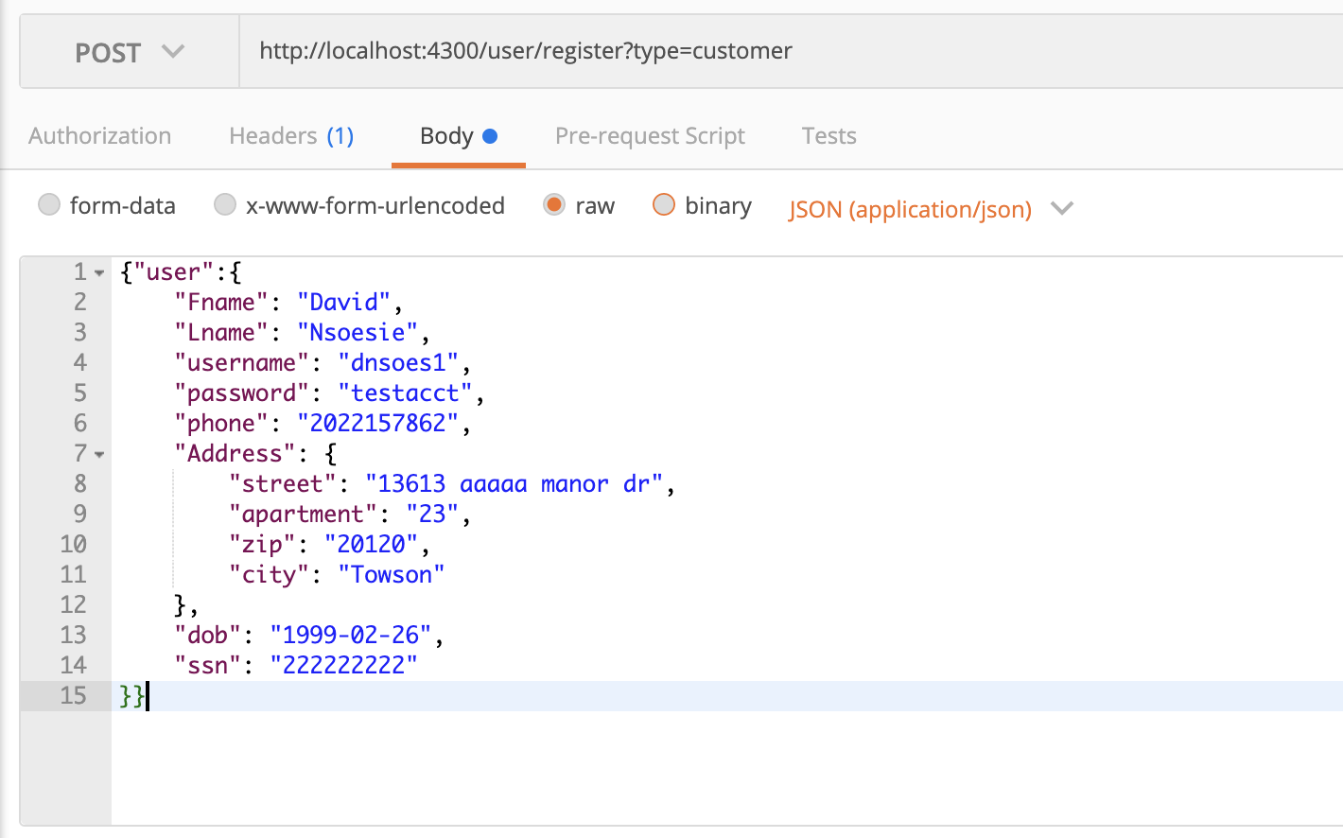

**Customer will be required to create an account where they can have access to the site. They will be required to fill in their names address and some personal information. In addition to that they will create a user name and password which they will use each time to access the site.**

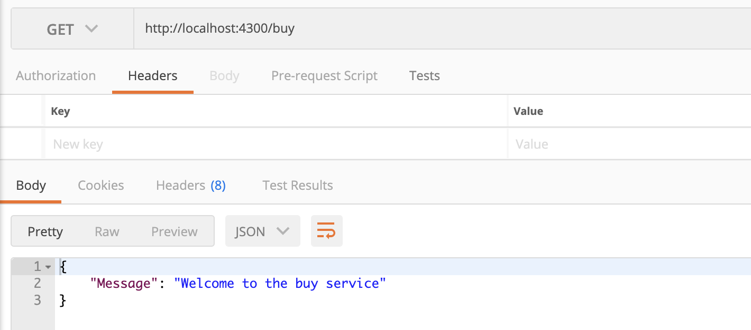

**When the customer logs in on the website the will receive a welcome greeting notification. And fromm there now they will now have the options to search for their cars or choose to do other services if they own a car purchased from the dealership.**

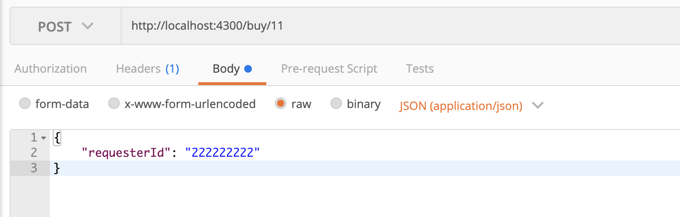

**Once the customer is log in they are now recognized by the system using a requested id which is their ssn. So when any purchases are being made or any maintenance are being done you can use the ssn to pull up the customer information.**

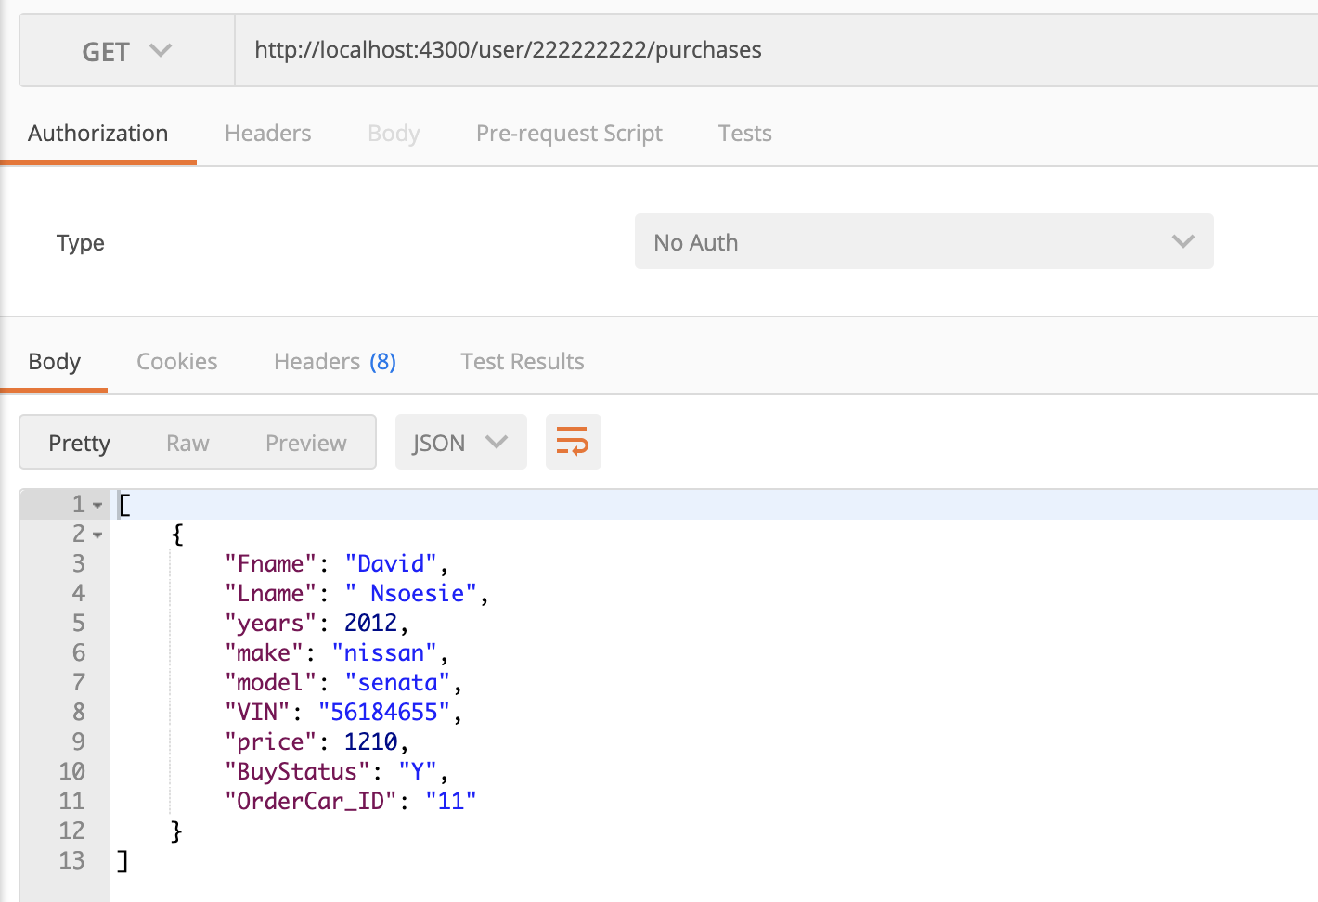

**When customers pick up a car to purchase it tells them is the car is still available.if the car is available the buy status will say “Y” for yes and “N” for no. Once that is done they will be given an ID number which we see in the picture above is 11. The Id number is used to recognized the car and its features.**

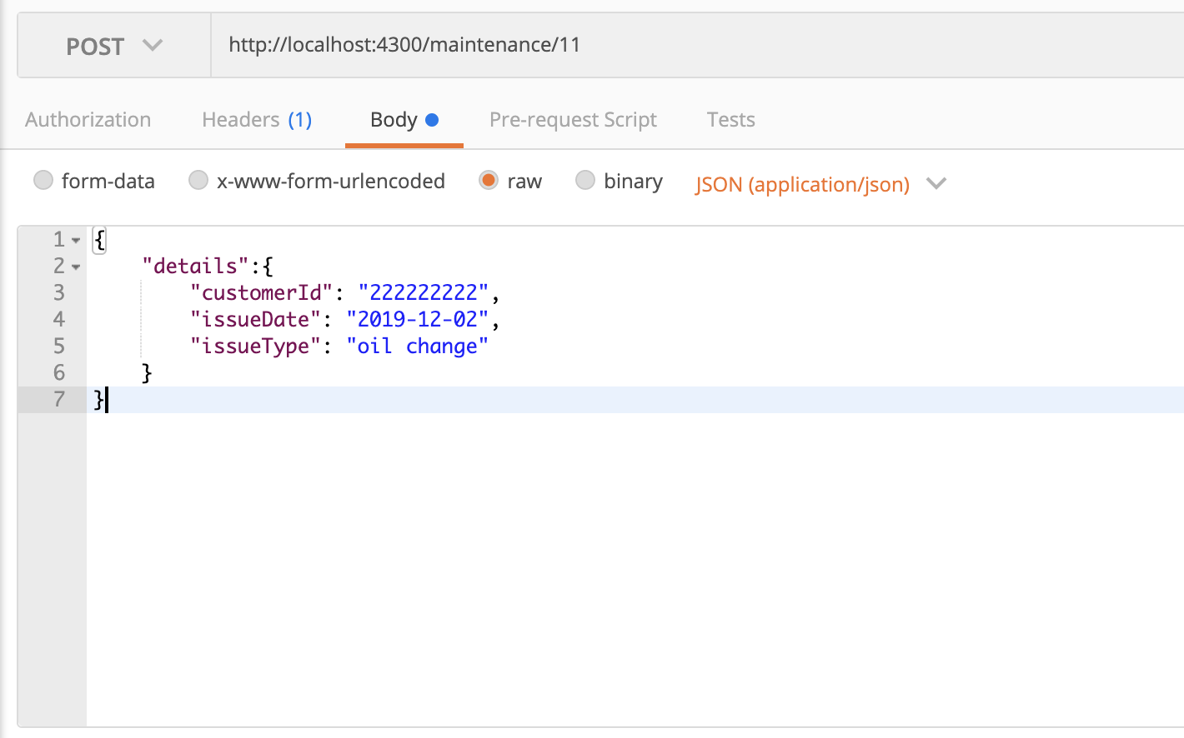

**When the customer makes a purchase they can use the id number to place maintenance order on their car. For example, the picture above shows us a customer who has an issues of oil change and needs maintenance. So in order to place the maintenance order they will need to use their customer id which is their ssn.**

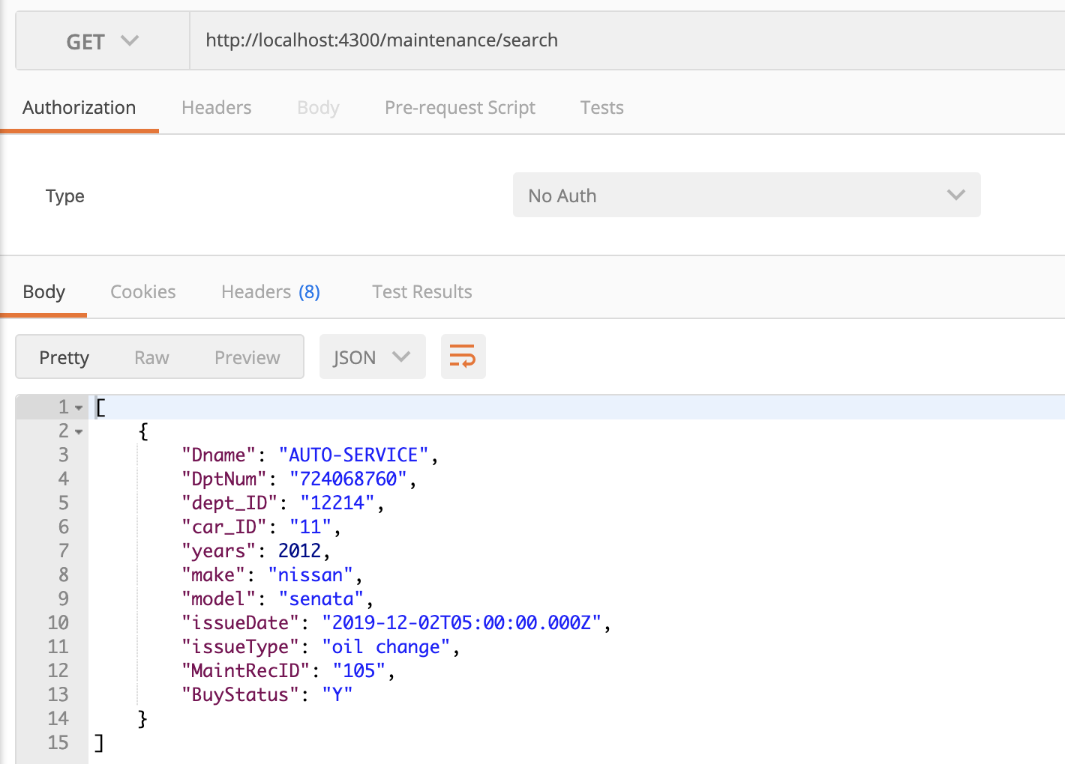

**The request order will look like the picture above. Where it will be sent to the AutoService Department. They will then perform the maintenance.**

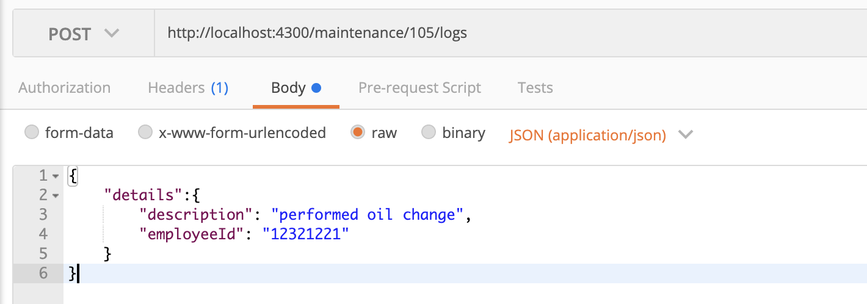

**Once the maintenance order is being place the the mechanics will receive it then perform the required services and then check it out on the employee from auto service. They will then get a description saying the services required has been performed.**

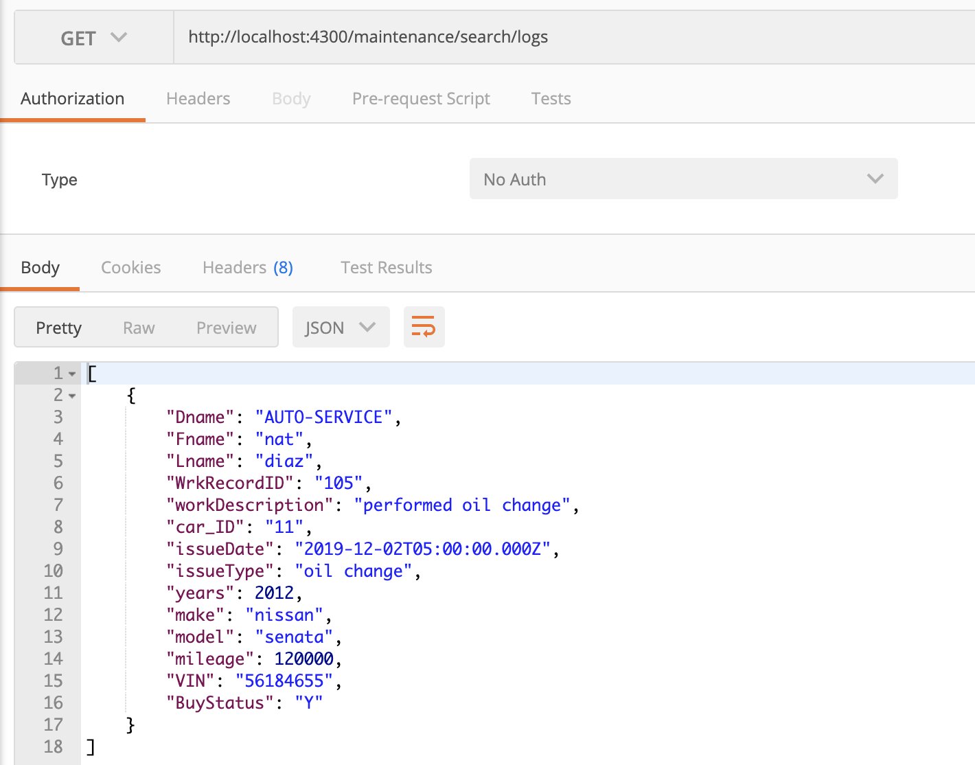

**Then the Auto service section will then printout a receipt showing all maintenance services carried out on the car .**